Software Engineering
Final project

Name: Hamza Awais
Reg No: L1f24bscs0229
Section: D-15
Semester: 4th

Project: Smart Cafeteria Management System
UI PROTOTYPE DESIGNS

1. Introduction

1.1 Project Overview
Smart Cafeteria Management System is a full-stack, responsive web application designed to make ordering food at a campus cafeteria fast, transparent, and easy to manage. The platform provides two separate portals — a Student/Staff Portal and a Cafeteria Manager (Admin) Portal — each built around what that type of user actually needs to do.
Students and staff can sign in, browse the live daily menu, add items to a cart, place an order, and track its status from "Preparing" to "Ready for Pickup" in real time. Cafeteria managers can view daily sales and order analytics, add or update menu items, control stock and pricing, and monitor the kitchen's order queue through a dedicated dashboard.
The system is fully responsive and works smoothly on desktop browsers, tablets, and mobile devices without losing any functionality or usability.

1.2 Motivation
Traditional cafeteria ordering usually means standing in long queues, paying with cash, and having no idea how far along your order actually is. This causes wasted time during short breaks, overcrowding at the counter, and frustration for both students and cafeteria staff. Smart Cafeteria Management System aims to digitize and simplify this entire experience by providing:
- A self-service ordering experience so students can order ahead and skip the line
- A real-time kitchen queue so staff always know what to prepare next
- Transparent order status tracking (Placed, Preparing, Ready, Picked Up)
- Live stock visibility so users know instantly if an item is low or sold out
- Quick cashless payment through a campus wallet

1.3 Scope
The scope of this project covers:
- User authentication (login and sign-up) for students, staff, and cafeteria managers
- Role-based access separating the ordering experience from the management experience
- Live, searchable menu with category filters and stock status indicators
- End-to-end order lifecycle: cart, checkout, confirmation, kitchen preparation, pickup
- Manager tools for adding, editing, and removing menu items with price and availability control
- A kitchen queue board for tracking and updating order status in real time
- Dashboards with sales and performance summaries for the cafeteria manager
- Fully responsive UI compatible with desktop, tablet, and mobile screens

2. System Analysis

2.1 Problem Statement
Cafeteria ordering on most campuses is still a manual, in-person process. Students waste valuable break time waiting in line, often without knowing if their preferred item is even still available. Cafeteria staff have no easy way to manage incoming orders, track which items are running low, or see which dishes sell best. Without a digital system connecting students and the kitchen, both sides experience delays, confusion, and lost efficiency. There is a clear need for one platform that lets students order ahead with confidence and gives managers the tools to run the cafeteria smoothly.

2.2 Stakeholders
Stakeholder | Role | Key Needs
Student / Staff | End user placing food orders | Quick browsing, easy ordering, order status tracking
Cafeteria Manager | Oversees menu and daily operations | Sales overview, menu control, stock management
Kitchen Staff | Prepares ordered items | Clear, live queue of incoming and in-progress orders
University Evaluators | Academic assessment | Documentation completeness, sound system design

2.3 Functional Requirements

Student / Staff-Side Requirements
- The system shall allow students and staff to sign in using their Campus ID.
- The system shall display a live daily menu with categories such as Meals, Snacks, Beverages, and Desserts.
- The system shall allow users to search and filter menu items by category or dietary preference.
- The system shall show real-time stock status for each item, such as In Stock, Only a Few Left, or Sold Out.
- The system shall allow users to add items to a cart and adjust quantities before checkout.
- The system shall calculate a transparent order summary, including subtotal, service fee, and total.
- The system shall allow payment through a digital campus wallet.
- The system shall generate a digital order confirmation with a unique order ID.
- The system shall display a live status tracker showing the order's progress: Placed, Preparing, Ready.

Manager-Side Requirements
- The system shall allow the cafeteria manager to sign in through a separate admin portal.
- The system shall display a dashboard with today's order count, revenue, and average preparation time.
- The system shall show a chart of top-selling menu items.
- The system shall allow the manager to add, edit, or remove menu items.
- The system shall allow the manager to set item price and toggle availability instantly.
- The system shall allow the manager to track remaining stock for each item.
- The system shall display a live kitchen queue separated into New, Preparing, and Ready stages.
- The system shall allow kitchen staff to move an order from one stage to the next with a single action.

2.4 Non-Functional Requirements
Category | Requirement
Responsiveness | Application must be fully usable on desktop, tablet, and mobile devices
Performance | Pages must load within 3 seconds on standard broadband or campus Wi-Fi
Usability | Intuitive UI requiring no training for placing or managing an order
Security | Passwords stored securely with hashing; role-based access prevents student access to manager tools
Scalability | Architecture must support adding new menu categories or cafeteria branches without core rewrites
Availability | System shall target 99.5% uptime during cafeteria operating hours
Compatibility | Supports Chrome, Firefox, Safari, and Edge (latest two versions each)
Accessibility | Sufficient color contrast on the dark theme; keyboard-navigable forms

3. System Design

3.1 Architecture Overview
Smart Cafeteria Management System follows a client-server architecture with a clear separation of concerns:
- Frontend (Client): A responsive single-page web application handling all UI rendering, menu browsing, cart, and checkout interactions.
- Backend (Server): A RESTful API server responsible for business logic, authentication, order processing, and database operations.
- Database: A relational database storing users, menu items, orders, and order status history.
- Hosting: Deployed on a cloud provider so the system is accessible from any device on campus or off-campus.

3.2 User Roles & Access Control
Role | Portal | Accessible Pages
Student / Staff | Ordering Portal | Browse Menu, Cart & Checkout, Order Confirmation
Cafeteria Manager | Admin Portal | Dashboard, Manage Menu, Kitchen Queue

3.3 Database Schema
Table | Key Columns | Purpose
users | id, name, campus_id, password_hash, role | Stores all student, staff, and manager accounts
menu_items | id, name, category, price, stock_count, is_available | Stores all food and beverage items on the menu
orders | id, user_id, total_amount, status, created_at | Records each order placed and its current status
order_items | id, order_id, menu_item_id, quantity, price | Stores each individual item within an order

3.4 Order Status Lifecycle
Status | Triggered By | Description
Placed | Student completes checkout | Order has been sent to the kitchen
Preparing | Kitchen staff starts the order | Food is currently being prepared
Ready | Kitchen staff marks order complete | Order is ready for pickup at the counter
Picked Up | Student collects the order | Order lifecycle is complete

01. Login / Sign-up Screen
- Serves as a secure entry point that allows students, staff, and managers to sign into the system using their specific Campus ID.
- Features a minimalist dark interface highlighting the system's core benefit of ordering ahead to skip the cafeteria lines.

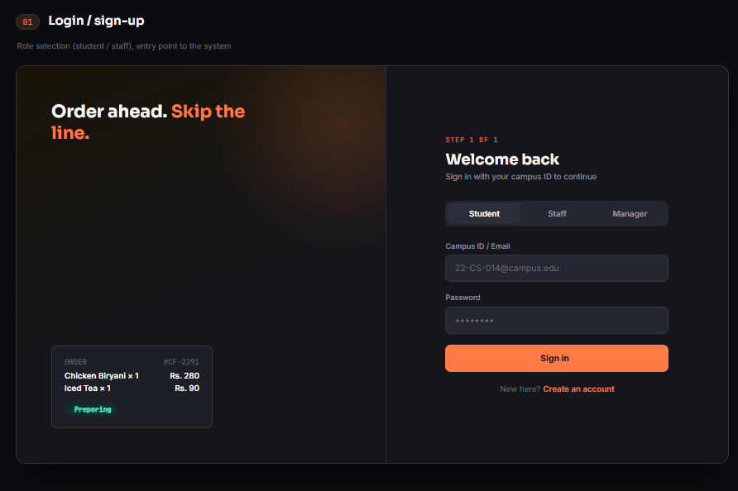

02. Browse Menu Screen
- Displays a live, searchable daily menu that lets users easily filter food items by dietary preferences and categories like meals, snacks, or desserts.
- Includes real-time pricing and highly visible stock status indicators, such as "Only 3 Left" or "Sold Out", to manage user expectations.
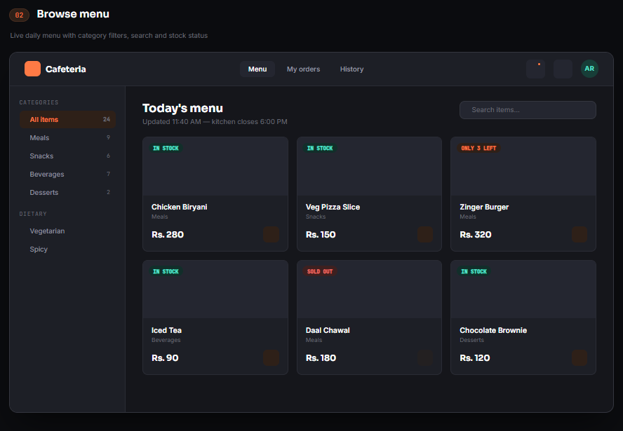

03. Cart & Checkout Screen
- Provides a clean summary interface where users can review their selected items, customize quantities, and view a transparent price breakdown.
- Dynamically calculates an estimated pickup time and integrates a quick, cashless payment method through a digital "Campus wallet".

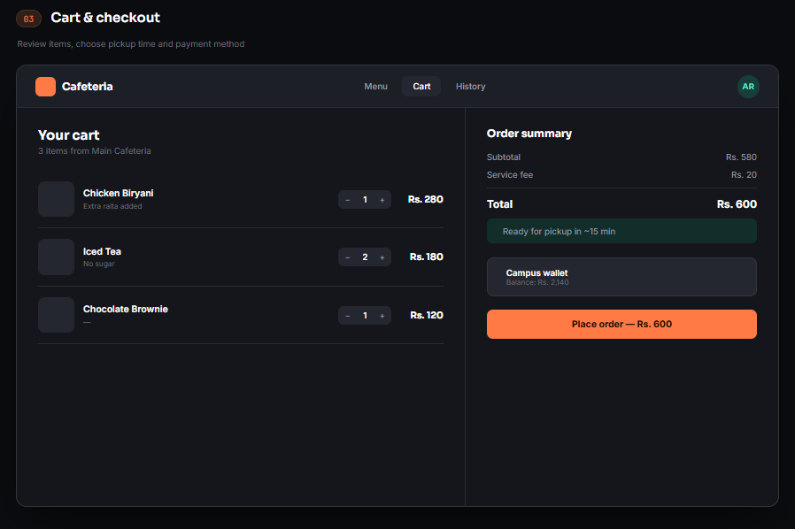

04. Order Confirmation Screen
- Acts as a digital receipt that presents the user with a distinct order ID alongside a clear list of purchased items and the final amount paid.
- Features an intuitive, color-coded live tracker that visually displays the food's real-time preparation progress from the kitchen.

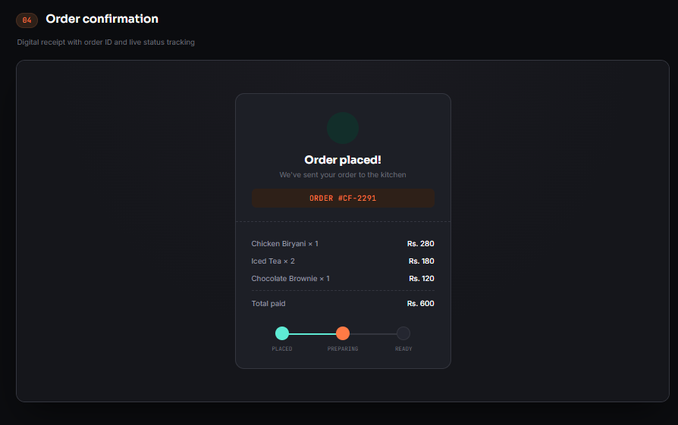

05. Manager Dashboard Screen
- Equips cafeteria management with a high-level administrative overview tracking daily sales volume, total order counts, and low-stock alerts.
- Visualizes performance analytics through a "Top selling items" chart and lists recent order queues with active status badges.

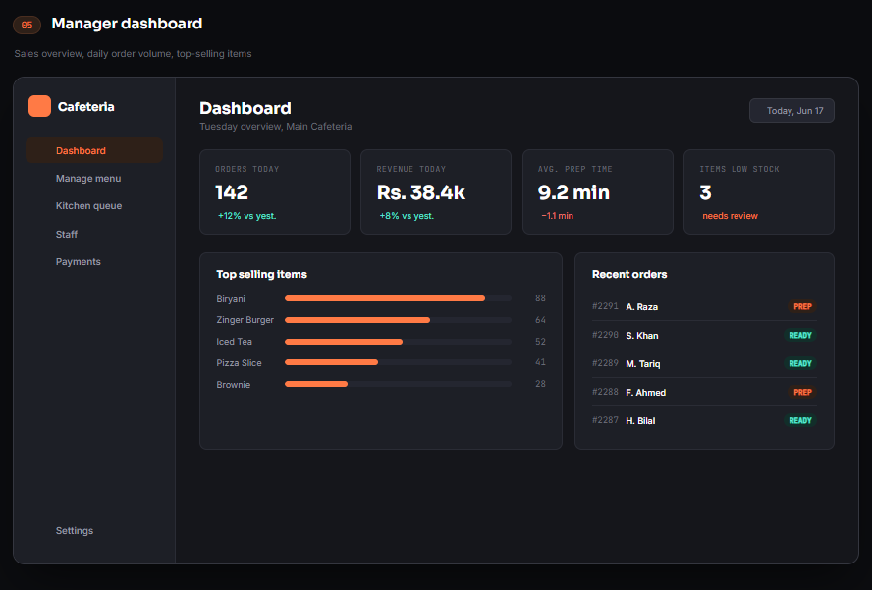

06. Manage Menu Screen
- Allows managers to seamlessly control the cafeteria's digital offerings by adding new items or updating active categories and pricing.
- Features instant toggle switches to adjust an item's availability on the fly and manually track remaining inventory counts.

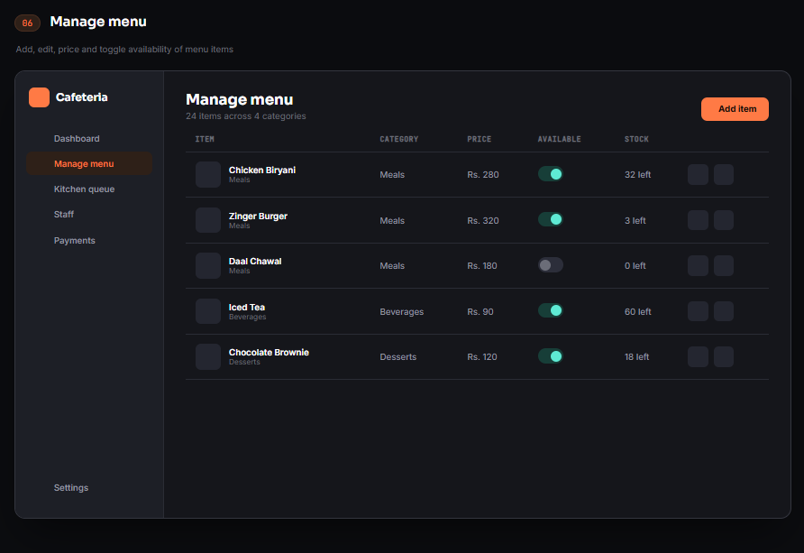

- Features instant toggle switches to adjust an item's availability on the fly and manually track remaining inventory counts.

07. Kitchen Order Queue Screen
- Provides the back-of-house kitchen staff with a live-updating, auto-refreshing ticket board separated into three distinct operational stages.
- Features interactive action buttons that allow staff to smoothly transition order tickets from "New" to "Preparing" and "Ready for Pickup".

